CMPG 325 – MILESTONE 1
CLIENT DESIGN REVIEW
Leano Travel Agency (Mahikeng) | Client ID: CL-059

1. Client Requirements
The client is Leano Travel Agency (Mahikeng), operating in the tourism industry. The network must use the assigned addressing block 192.168.32.0/24 and provide appropriate connectivity and network services for the departments in the scenario.
Requirement | Client Requirement | How the Network Meets It
Assigned organisation | Leano Travel Agency (Mahikeng) | The network is designed around the client's departmental structure.
Industry | Tourism | The design separates business functions while allowing required communication between departments.
Addressing block | 192.168.32.0/24 | The /24 block is subnetted into /28 networks, one for each VLAN.
Department separation | Administration, Travel Operations, Finance, IT Server, Shared Printer | Each department/service is placed in its own VLAN and IP subnet.
Inter-VLAN communication | Required between appropriate departments | Router-on-a-Stick provides Layer 3 routing between the VLANs.
Server security constraint | Server-room access restricted to authorised IT staff only | The IT Server resources are isolated in VLAN 40 and access can be controlled through routing/ACL policy.
CR8 change request | Shared printer zone serving two departments that currently cannot print | VLAN 50 contains the shared printer and is reachable from Travel Operations and Finance through inter-VLAN routing.
Testing | End-to-end connectivity and assigned challenge must be demonstrated | Ping tests and Packet Tracer verification commands are used as evidence.

2. Physical Topology

A star topology was selected for the physical network. In a star topology, end devices connect back to a central switch. This is appropriate for the travel agency because it is simple to install, easy to troubleshoot, and allows one end-device connection to fail without bringing down the other connections. The switch also provides a central point from which VLANs can be assigned and managed.
The router is connected to the switch using a single physical link. That link is configured as a trunk so that it can carry traffic for VLANs 10, 20, 30, 40 and 50. This physical design supports the required Router-on-a-Stick implementation.

2.1 Physical Topology Diagram
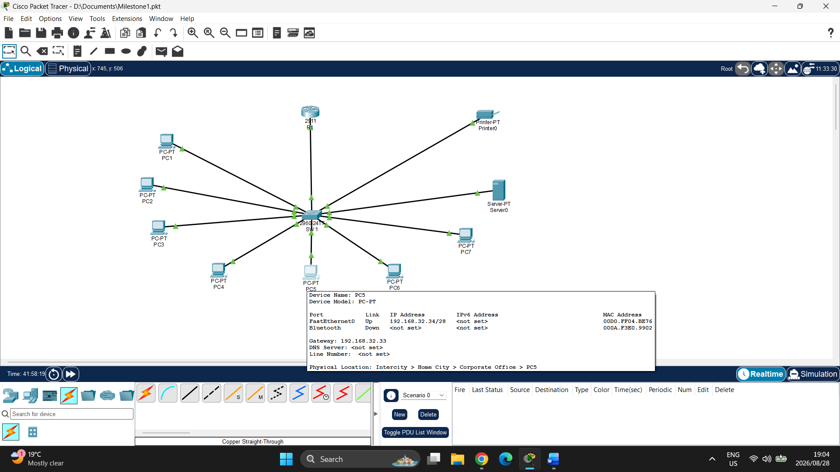

2.2 Devices and Their Roles
Device | Role
R1 – Router | Performs Layer 3 routing between the VLANs using Router-on-a-Stick sub-interfaces. Each sub-interface acts as the default gateway for its VLAN.
SW1 – Switch | Provides Layer 2 connectivity for the end devices, creates/maintains the VLANs, assigns access ports to VLANs, and carries tagged VLAN traffic over the trunk to R1.
PC1–PC7 | Represent client computers belonging to the Administration, Travel Operations, Finance and IT areas.
Server | Provides the server resource for the IT Server area and is placed in VLAN 40.
Shared Printer | Provides the shared printing service required by the CR8 change request and is isolated in VLAN 50.

3. Logical Topology / VLAN Design

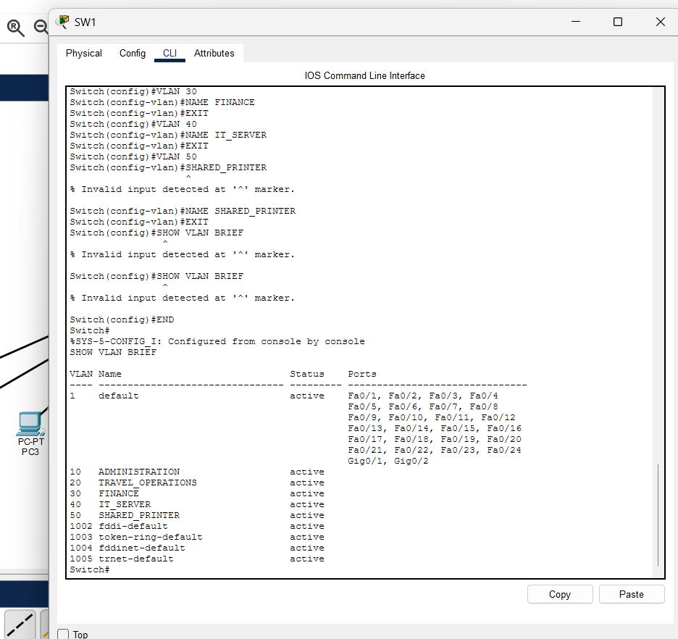

The network is logically divided into five VLANs. A VLAN is a logical network segment that separates devices at Layer 2 even when they are connected to the same physical switch. Each VLAN is assigned its own /28 IP subnet and its own default gateway on R1. This improves organisation, limits unnecessary broadcast traffic, and allows routing/security policies to be applied between departments.
VLAN | Name | Network | Gateway | Purpose
10 | ADMINISTRATION | 192.168.32.0/28 | 192.168.32.1 | Administration PCs
20 | TRAVEL OPERATIONS | 192.168.32.16/28 | 192.168.32.17 | Travel Operations PCs
30 | FINANCE | 192.168.32.32/28 | 192.168.32.33 | Finance PCs
40 | IT SERVER | 192.168.32.48/28 | 192.168.32.49 | IT workstation and server
50 | SHARED PRINTER | 192.168.32.64/28 | 192.168.32.65 | Shared printer

3.1 Communication Rules
The following communication policy describes the intended logical communication. Devices in the same VLAN can communicate locally through the switch. Communication between different VLANs must pass through R1, where routing/security policy can be applied.
Source | Destination | Communication Rule
Administration | Travel Operations, Finance, IT Server, Shared Printer | Allowed as required by the network design; inter-VLAN traffic uses R1.
Travel Operations | Administration, Finance, IT Server, Shared Printer | Allowed. Travel Operations must be able to use the shared printer for CR8.
Finance | Administration, Travel Operations, IT Server, Shared Printer | Allowed. Finance must be able to use the shared printer for CR8.
IT Server | Authorised IT staff / required network services | Access to the server area should be restricted to authorised IT staff in accordance with the design constraint.
Shared Printer | Travel Operations and Finance (required) | Must accept printing traffic from the two departments required by CR8; traffic crosses R1.

4. IP Addressing Plan
The client was assigned 192.168.32.0/24. The block is divided into /28 subnets. A /28 contains 16 total addresses: one network address, 14 usable host addresses, and one broadcast address. The first usable address in each subnet is used as the default gateway on R1.
VLAN | Network | Subnet Mask | Usable Hosts | Host Range | Gateway | Purpose
10 | 192.168.32.0/28 | 255.255.255.240 | 14 | 192.168.32.1–192.168.32.14 | 192.168.32.1 | Administration
20 | 192.168.32.16/28 | 255.255.255.240 | 14 | 192.168.32.17–192.168.32.30 | 192.168.32.17 | Travel Operations
30 | 192.168.32.32/28 | 255.255.255.240 | 14 | 192.168.32.33–192.168.32.46 | 192.168.32.33 | Finance
40 | 192.168.32.48/28 | 255.255.255.240 | 14 | 192.168.32.49–192.168.32.62 | 192.168.32.49 | IT Server
50 | 192.168.32.64/28 | 255.255.255.240 | 14 | 192.168.32.65–192.168.32.78 | 192.168.32.65 | Shared Printer

4.1 Assigned Device Addresses
Device | VLAN | IP Address | Default Gateway
PC1 | 10 | 192.168.32.2 | 192.168.32.1
PC2 | 10 | 192.168.32.3 | 192.168.32.1
PC3 | 20 | 192.168.32.18 | 192.168.32.17
PC4 | 20 | 192.168.32.19 | 192.168.32.17
PC5 | 30 | 192.168.32.34 | 192.168.32.33
PC6 | 30 | 192.168.32.35 | 192.168.32.33
PC7 | 40 | 192.168.32.50 | 192.168.32.49
Server | 40 | 192.168.32.51 | 192.168.32.49
Shared Printer | 50 | 192.168.32.66 | 192.168.32.65

5. Router-on-a-Stick Design
Router-on-a-Stick is used because the design has one router physical interface connected to the switch but needs to route traffic between five VLANs. The router's G0/0 interface uses sub-interfaces for each VLAN. Each sub-interface has an 802.1Q VLAN tag and an IP address that serves as the default gateway for that VLAN.
Router Sub-interface | VLAN Encapsulation | Gateway IP
G0/0.10 | 802.1Q VLAN 10 | 192.168.32.1
G0/0.20 | 802.1Q VLAN 20 | 192.168.32.17
G0/0.30 | 802.1Q VLAN 30 | 192.168.32.33
G0/0.40 | 802.1Q VLAN 40 | 192.168.32.49
G0/0.50 | 802.1Q VLAN 50 | 192.168.32.65

6. Testing and Evidence
PC1 to PC3 ping
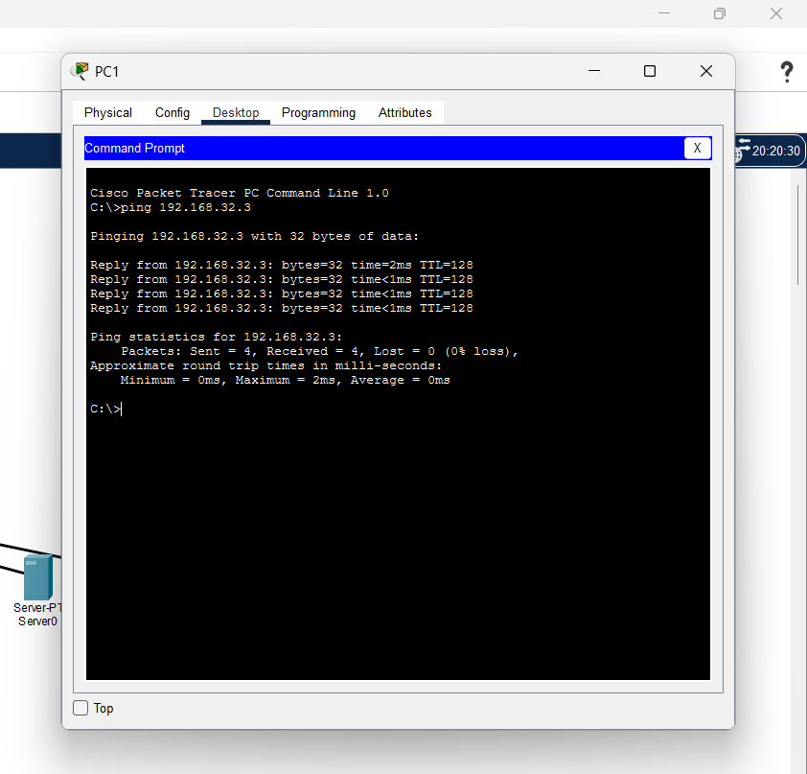

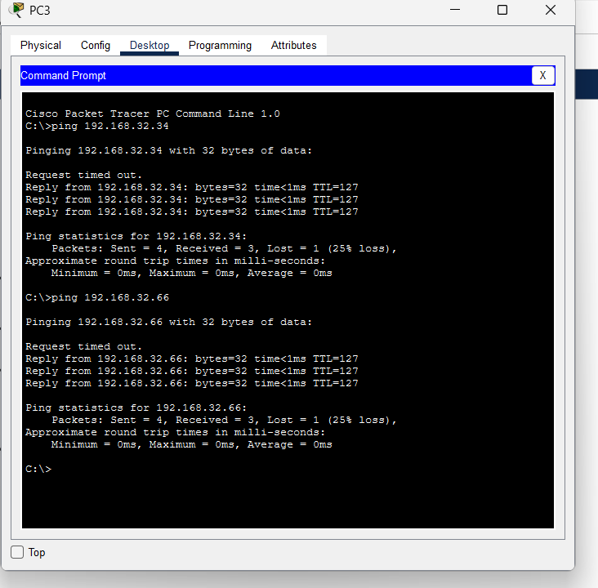 PC3 to Printer ping. And PC3 to PC5 ping to show inter-vlan routing

Evidence/Test | Purpose
show vlan brief | Verify VLANs 10, 20, 30, 40 and 50 exist on SW1 and that access ports are assigned correctly.
show ip interface brief | Verify R1 sub-interfaces are up/up and have the expected gateway addresses.
PC3 → PC5 ping | Tests inter-VLAN routing from Travel Operations (VLAN 20) to Finance (VLAN 30).
PC3 → Printer ping | Tests the CR8 shared-printer path from Travel Operations (VLAN 20) to VLAN 50.

